|  |  |  |  |
| --- | --- | --- | --- |
| ID | Description | Dependencies | Length [days] |
| T1 | Requests manager | T6 | 7 |
| T2 | Shared rides manager | T1 | 14 |
| T3 | Reservations manager | T15 | 7 |
| T4 | Registration manager | T16 | 7 |
| T5 | Authentication manager | T16 | 10 |
| T6 | Taxi management | T15 | 20 |
| T7 | Emergency manager | T6 | 10 |
| T8 | Taxi driver interface | T11,T12,T13 | 30 |
| T9 | Web interface | T11,T12,T13 | 30 |
| T10 | Mobile interface | T11,T12,T13 | 30 |
| T11 | Service broker |  | 10 |
| T12 | Notification center |  | 7 |
| T13 | Internal message dispatcher | T1,T2,T3,T7,T11 | 14 |
| T14 | Web server | T12 | 2 |
| T15 | Datawarehouse |  | 5 |
| T16 | User Database |  | 2 |
| T17 | Analyzer | T15 | 3 |
| T18 | Documents creation |  | 25 |
| T19 | Integration testing | Everything done | 30 |
| T20 | Interfaces translation | T18 | 2 |

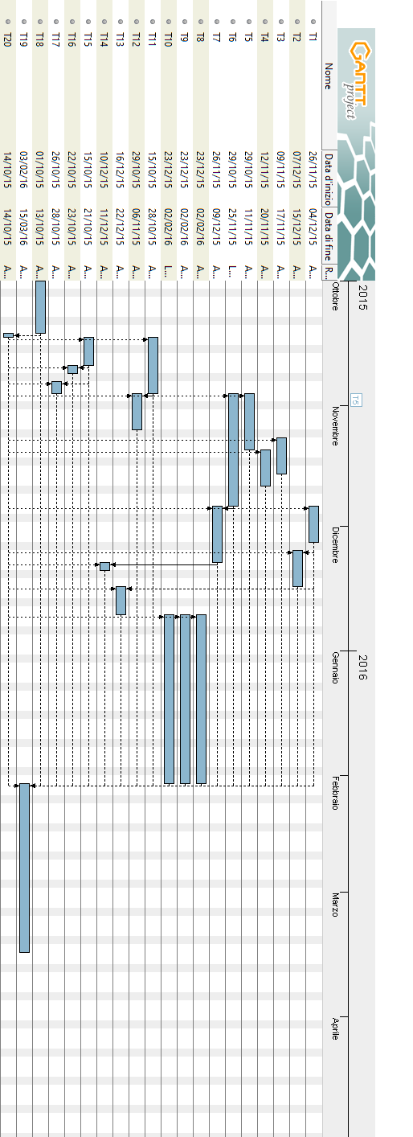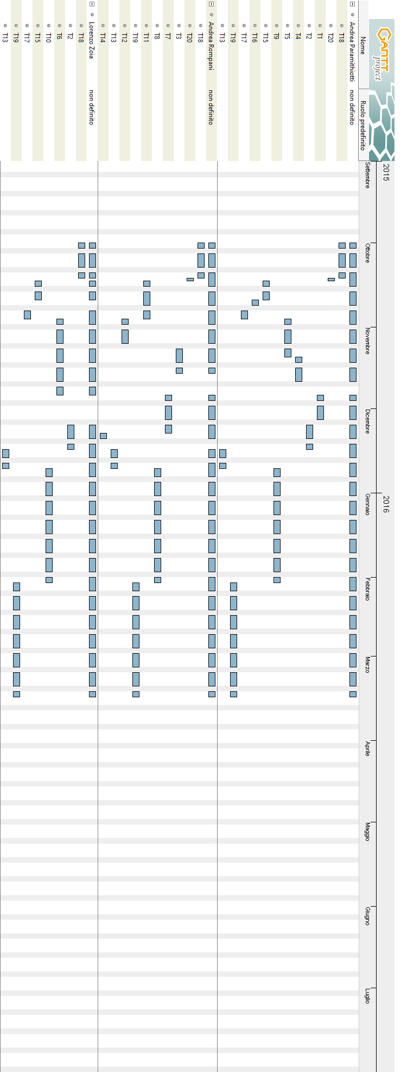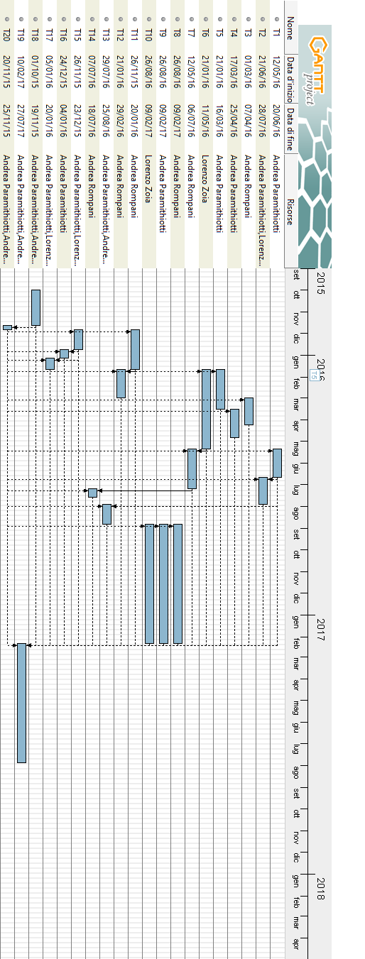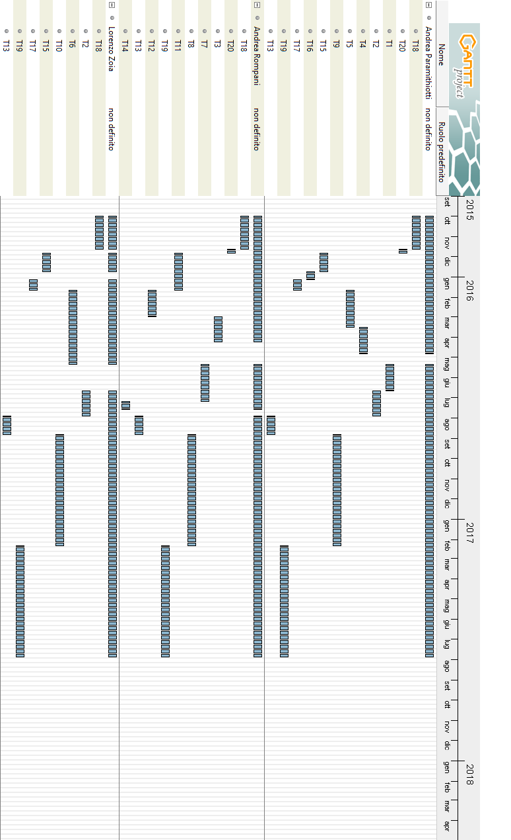

|  |  |  |  |
| --- | --- | --- | --- |
| ID | Risk | Probability | Effects |
| 1 | Organizational financial problems force reductions in the  project budget. | Low | Catastrophic |
| 2 | Unrealistic schedule and underestimation | Low | Serious |
| 3 | It is impossible to recruit staff with the skills required for the project. | Low | Catastrophic |
| 4 | Key staff are ill at critical times in the project. | Moderate | Serious |
| 5 | Faults in reusable software components have to be repaired before these components are reused. | Moderate | Serious |
| 6 | Changes to requirements that require major design rework are proposed | Low | Serious |
| 7 | The organization is restructured so that different management are responsible for the project | Low | Serious |
| 8 | The database used in the system cannot process as many transactions per second as expected | Low | Serious |
| 9 | Because of bottom up design, the integration testing takes more time than expected | Moderate | Serious |
| 10 | Network availability reduction due to ISP problems | Low | Catastrophic |
| 11 | Major changes in mobile operating systems programming specifications | Low | Moderate |
| 12 | Client requires changes in the user interface design | Low | Moderate |
| 13 | Unclear requirements | Low | Moderate |
| 14 | The server is unable to manage all the requests | Low | Negligible |
| 15 | The communication protocol between services becomes unusable or deprecated by industry standard | Very Low | Moderate |
| 16 | Mutually assured destruction by the big nation of earth creating a post-apocalyptic world where the only currency are bottle caps | Very Low | Zombies and rotting gouls |

|  |  |
| --- | --- |
| Risk | Strategy and recovery actions |
| 1 | Underline to the management how the project is relevant and fundamental for the business, showing the pros of carrying on the project |
| 2 | Reorganize the team work in order to release a working demo for the client |
| 3 | Alert client for the recruitment difficulties, and in consequence of the possible delays |
| 4 | Reorganize the team in order to have the other team members working on the important missing parts |
| 5 | Replace the non-working components with reliable compatible and reliable versions |
| 6 | Warn the client of the possible raise in terms of cost and time |
| 7 | Prepare a document to express the importance of the project and another document to explain the key points of the project to the new management |
| 8 | Investigate the possibility of buying an higher performance database or investigate problems in queries performance |
| 9 | Explain the motivations to the client and the manager, underlining the importance of the integration testing on the reliability of the program |
| 10 | Contact ISP customer support and investigate the possibility of changing ISP |
| 11 | Consider the possibility to support the new operating system in a second moment, to avoid a delay in the schedule. Have the programmers keep up to date with the new features |
| 12 | Trace the changes impact on the schedule and communicate to the customer the possible delays caused by the changes |
| 13 | Ask the client for better requirements and try to avoid other misunderstandings |
| 14 | Due to the partitioning in services and the possibility to have multiple instances of the same service, a possible peak hour usage can be avoided by adding more instances of the most used services |
| 15 | Consider to have a protocol agnostic communication between services |
| 16 | Provide a document explaining the dangers or a lawless world, also consider the possibility of buying a wrist-mounted device.  Other than that, RUN LIKE HELL!!!! and remember to buy a flamethrower, and if it’s possible a rocket launcher, also beware of the radiation poisoning that can be bad for the health |